Chapter 6, Solution 41.

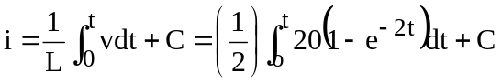

= 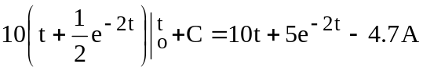

Note, we get C = –4.7 from the initial condition for i needing to be 0.3 A.

We can check our results be solving for v = Ldi/dt.

v = 2(10 – 10e^{–2t})V which is what we started with.

At t = l s, i = 10 + 5e⁻² – 4.7 = 10 + 0.6767 – 4.7 = 5.977 A

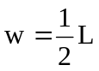i² = 35.72J

